CS 5404 Assignment 4

Wei Luo

**Introduction**

The “point.mat” includes two matrixes “point1” and “point2” with 100 points information that I select from these two images by “GetPoints.m”. The “point1” with 10 points in each image is for the first experiment, and the “point2” with 15 points in each image is for the second experiment.

Point1:

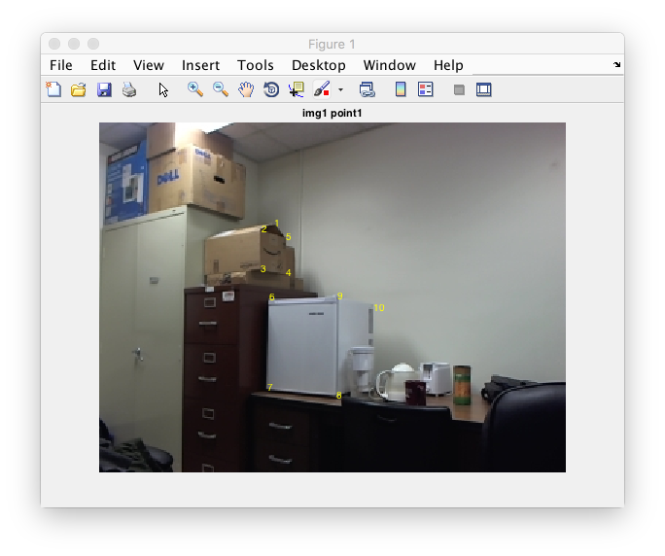

|  |  |  |
| --- | --- | --- |
|  | **X1** | **Y1** |
| **1** | 120.750000000000 | 70.7499999999999 |
| **2** | 111.750000000000 | 74.7499999999999 |
| **3** | 111.250000000000 | 101.750000000000 |
| **4** | 128.750000000000 | 104.250000000000 |
| **5** | 128.750000000000 | 79.7499999999999 |
| **6** | 117.250000000000 | 121.250000000000 |
| **7** | 115.750000000000 | 183.250000000000 |
| **8** | 163.250000000000 | 188.250000000000 |
| **9** | 163.750000000000 | 120.750000000000 |
| **10** | 188.750000000000 | 128.250000000000 |

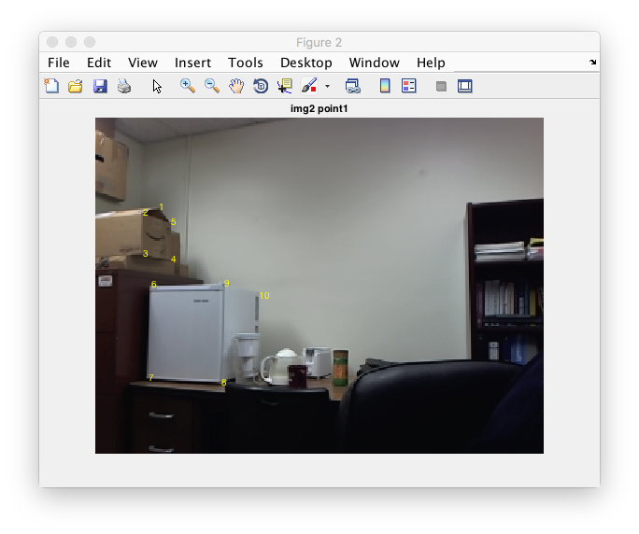

|  |  |  |
| --- | --- | --- |
|  | **X2** | **Y2** |
| **1** | 45.7500000000000 | 65.2499999999999 |
| **2** | 34.2500000000000 | 69.2499999999999 |
| **3** | 34.2500000000000 | 98.2499999999999 |
| **4** | 54.7500000000000 | 102.250000000000 |
| **5** | 54.2500000000000 | 75.7499999999999 |
| **6** | 40.2500000000000 | 120.250000000000 |
| **7** | 38.2500000000000 | 187.250000000000 |
| **8** | 90.7500000000000 | 190.250000000000 |
| **9** | 92.7500000000000 | 119.750000000000 |
| **10** | 117.250000000000 | 128.250000000000 |

Point2:

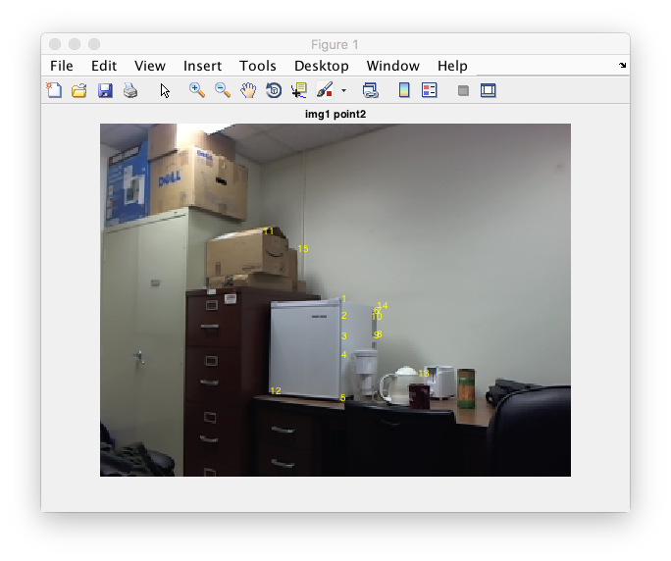

|  |  |  |
| --- | --- | --- |
|  | **X1** | **Y1** |
| **1** | 164.250000000000 | 120.750000000000 |
| **2** | 164.250000000000 | 131.750000000000 |
| **3** | 164.250000000000 | 145.750000000000 |
| **4** | 164.250000000000 | 158.250000000000 |
| **5** | 163.750000000000 | 187.750000000000 |
| **6** | 186.250000000000 | 128.750000000000 |
| **7** | 188.250000000000 | 128.750000000000 |
| **8** | 188.250000000000 | 144.750000000000 |
| **9** | 186.250000000000 | 145.250000000000 |
| **10** | 184.250000000000 | 132.750000000000 |
| **11** | 111.250000000000 | 74.2499999999999 |
| **12** | 115.750000000000 | 183.250000000000 |
| **13** | 216.750000000000 | 171.250000000000 |
| **14** | 188.750000000000 | 125.250000000000 |
| **15** | 134.750000000000 | 86.7499999999999 |

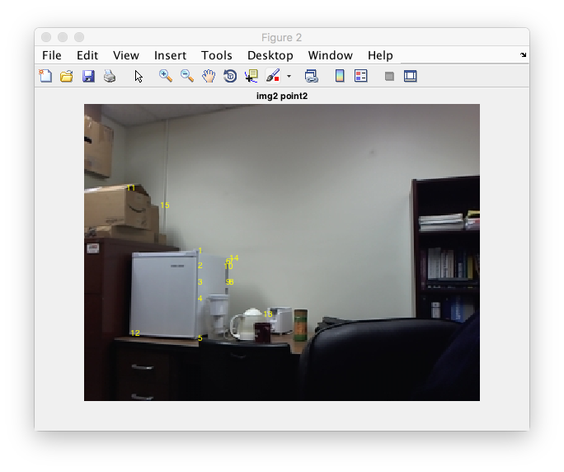

|  |  |  |
| --- | --- | --- |
|  | **X2** | **Y2** |
| **1** | 92.7500000000000 | 119.750000000000 |
| **2** | 92.2500000000000 | 131.750000000000 |
| **3** | 92.2500000000000 | 145.250000000000 |
| **4** | 92.2500000000000 | 158.750000000000 |
| **5** | 92.2500000000000 | 190.250000000000 |
| **6** | 115.250000000000 | 128.750000000000 |
| **7** | 117.750000000000 | 128.750000000000 |
| **8** | 117.750000000000 | 145.250000000000 |
| **9** | 115.250000000000 | 145.250000000000 |
| **10** | 113.250000000000 | 132.250000000000 |
| **11** | 34.2500000000000 | 69.2499999999999 |
| **12** | 37.7500000000000 | 186.750000000000 |
| **13** | 145.250000000000 | 171.250000000000 |
| **14** | 117.750000000000 | 125.750000000000 |
| **15** | 61.7500000000000 | 83.2499999999999 |

The “HW4_withoutBonus.m” and “HW4_withBonus.m” will directly use these information of points to finish these two experiment.

1. **If you select N <= 4 points, what will happen? If you select N >> 4 points, will the result be better than that with N = 4 points?**

There are 4 tests in this experiment.

**For the first test**, I use first three points in point1 to the code “HW4_withoutBonus.m” which set the value of “experiment” as 1.

*The points I use: (x1, y1 is the coordinate of points in image1; x2, y2 is the coordinate of points in image2)*

|  |  |  |  |  |
| --- | --- | --- | --- | --- |
|  | **x1** | **y1** | **x2** | **y2** |
| **1** | 120.75000000000 | 70.749999999999 | 45.750000000000 | 65.249999999999 |
| **2** | 111.75000000000 | 74.749999999999 | 34.250000000000 | 69.249999999999 |
| **3** | 111.25000000000 | 101.75000000000 | 34.250000000000 | 98.249999999999 |

*Assume h33 = 1, we got h1 as below:*

|  |  |  |
| --- | --- | --- |
| -0.0828486694406599 | 0.293344006779261 | 0 |
| -0.594983462104761 | 1.23217497516879 | 0 |
| -0.0112579947842898 | 0.00840110230557387 | 1 |

*We computed the (x1, y1) with this h1, we got the (x2, y2) as below:*

|  |  |
| --- | --- |
| **x2** | **y2** |
| 45.7499999999997 | 65.2499999999998 |
| 34.2500000000000 | 69.2499999999999 |
| 34.2500000000000 | 98.2499999999999 |

Which I believe is quite close to the real one. The average difference of each point is really closed to 0. The result is good.

*Then I assume ||h|| = 1, we got h2 as below:*

|  |  |  |
| --- | --- | --- |
| 0.0127529840039472 | -0.00320056760158779 | -0.999693078813834 |
| 0.00615744732525477 | -0.00390510576049074 | -0.0196895709700052 |
| 0.000114342945945749 | -9.82251357615811e-05 | 1.30630650944131e-06 |

*We computed the (x1, y1) with this h2, we got the (x2, y2) as below:*

|  |  |
| --- | --- |
| **x2** | **y2** |
| 45.7500000000004 | 65.2499999999945 |
| 34.2499999999998 | 69.2500000000084 |
| 34.2499999999993 | 98.2499999999975 |

The result also really good and the average difference of each point is almost 0.

**For the second test**, I use first four points in point1 to the code “HW4_withoutBonus.m” which set the value of “experiment” as 2.

*The points I use: (x1, y1 is the coordinate of points in image1; x2, y2 is the coordinate of points in image2)*

|  |  |  |  |  |
| --- | --- | --- | --- | --- |
|  | **x1** | **y1** | **x2** | **y2** |
| **1** | 120.75000000000 | 70.749999999999 | 45.750000000000 | 65.249999999999 |
| **2** | 111.75000000000 | 74.749999999999 | 34.250000000000 | 69.249999999999 |
| **3** | 111.25000000000 | 101.75000000000 | 34.250000000000 | 98.249999999999 |
| **4** | 128.75000000000 | 104.25000000000 | 54.750000000000 | 102.25000000000 |

*Assume h33 = 1, we got h1 as below:*

|  |  |  |
| --- | --- | --- |
| 1.53343859022795 | 0.159762188668265 | -141.349987630528 |
| 0.0617577526244428 | 1.69364966881863 | -48.6750440436219 |
| -0.000545969389834194 | 0.00382536909773266 | 1 |

*We computed the (x1, y1) with this h1, we got the (x2, y2) as below:*

|  |  |
| --- | --- |
| **x2** | **y2** |
| 45.7500000000000 | 65.2499999999999 |
| 34.2500000000000 | 69.2499999999999 |
| 34.2500000000000 | 98.2499999999999 |
| 54.7500000000000 | 102.250000000000 |

Which I believe is quite close to the real one and the average difference with origin points is almost 0. The result is really good.

*Then I assume ||h|| = 1, we got h2 as below:*

|  |  |  |
| --- | --- | --- |
| -0.0102559495989581 | -0.00106852196492453 | 0.945377490450028 |
| -0.000413048046434265 | -0.0113274739446664 | 0.325548551351840 |
| 3.65155850855817e-06 | -2.55848456817185e-05 | -0.00668820448154858 |

*We computed the (x1, y1) with this h2, we got the (x2, y2) as below:*

|  |  |
| --- | --- |
| **x2** | **y2** |
| 45.7499999518299 | 65.2499999564285 |
| 34.2500000590705 | 69.2500000513759 |
| 34.2499999722907 | 98.2499999724175 |
| 54.7500000176338 | 102.250000019775 |

The result also really good and the average difference with origin points is a little big larger than the points we get from h1, but it is also almost 0.

**For the third test**, I use first five points in point1 to the code “HW4_withoutBonus.m” which set the value of “experiment” as 3.

*The points I use: (x1, y1 is the coordinate of points in image1; x2, y2 is the coordinate of points in image2)*

|  |  |  |  |  |
| --- | --- | --- | --- | --- |
|  | **x1** | **y1** | **x2** | **y2** |
| **1** | 120.75000000000 | 70.749999999999 | 45.750000000000 | 65.249999999999 |
| **2** | 111.75000000000 | 74.749999999999 | 34.250000000000 | 69.249999999999 |
| **3** | 111.25000000000 | 101.75000000000 | 34.250000000000 | 98.249999999999 |
| **4** | 128.75000000000 | 104.25000000000 | 54.750000000000 | 102.25000000000 |
| **5** | 128.75000000000 | 79.749999999999 | 54.250000000000 | 75.749999999999 |

*Assume h33 = 1, we got h1 as below:*

|  |  |  |
| --- | --- | --- |
| 1.02360704244933 | 0.0147443438442098 | -83.9197914548975 |
| -0.0220102486729388 | 1.00648186003174 | -9.59286452249037 |
| -0.000971931300105956 | 0.000278821663656865 | 1 |

*We computed the (x1, y1) with this h1, we got the (x2, y2) as below:*

|  |  |
| --- | --- |
| **x2** | **y2** |
| 45.1301628025254 | 65.3371184615358 |
| 34.6080306622956 | 69.2611582920580 |
| 34.1830773472457 | 98.2002029917628 |
| 54.6576153625773 | 102.329767986886 |
| 54.6711443951124 | 75.6217299279814 |

The average distance between the results and origin points is 0.4408 pixels, the standard deviation is 0.3295 pixels, due to the fact that the points select by human’s eyes may not accurately correct, the mistake may become larger when the number of wrong points rose up. Even through result is not good as the front one, when N = 4, I still think it is a good result.

*Then I assume ||h|| = 1, we got h2 as below:*

|  |  |  |
| --- | --- | --- |
| 0.0110379428952570 | 0.000350465555656137 | -0.951909410029319 |
| 0.00129464566405963 | 0.0103993126797081 | -0.305907493709480 |
| 7.69419374865024e-06 | 6.68015800337768e-06 | 0.00756964101670783 |

*We computed the (x1, y1) with this h2, we got the (x2, y2) as below:*

|  |  |
| --- | --- |
| **x2** | **y2** |
| 45.2237691842695 | 65.3383550003762 |
| 34.4702198836635 | 69.0033557124214 |
| 34.2350842008512 | 98.4316088189298 |
| 54.6375210898851 | 102.078390908798 |
| 54.6766480734454 | 75.8960169511090 |

The result is good and the average difference with origin points is 0.3678 pixels, the standard deviation is 0.3017 which is better than results got by h1, but not as good as when the N <= 4.

**For the forth test**, I use all ten points in point1 to the code “HW4_withoutBonus.m” which set the value of “experiment” as 4.

*The points I use: (x1, y1 is the coordinate of points in image1; x2, y2 is the coordinate of points in image2)*

|  |  |  |  |  |
| --- | --- | --- | --- | --- |
|  | **x1** | **y1** | **x2** | **y2** |
| **1** | 120.75000000000 | 70.749999999999 | 45.7500000000000 | 65.2499999999999 |
| **2** | 111.75000000000 | 74.749999999999 | 34.2500000000000 | 69.2499999999999 |
| **3** | 111.25000000000 | 101.75000000000 | 34.2500000000000 | 98.2499999999999 |
| **4** | 128.75000000000 | 104.25000000000 | 54.7500000000000 | 102.250000000000 |
| **5** | 128.75000000000 | 79.749999999999 | 54.2500000000000 | 75.7499999999999 |
| **6** | 117.25000000000 | 121.25000000000 | 40.2500000000000 | 120.250000000000 |
| **7** | 115.75000000000 | 183.25000000000 | 38.2500000000000 | 187.250000000000 |
| **8** | 163.25000000000 | 188.25000000000 | 90.7500000000000 | 190.250000000000 |
| **9** | 163.75000000000 | 120.75000000000 | 92.7500000000000 | 119.750000000000 |
| **10** | 188.75000000000 | 128.25000000000 | 117.250000000000 | 128.250000000000 |

*Assume h33 = 1, we got h1 as below:*

|  |  |  |
| --- | --- | --- |
| 1.38727417135552 | -0.0144498543899960 | -114.097956557862 |
| 0.171725994608094 | 1.24853761630076 | -33.6473502745794 |
| 0.00127029791203325 | -4.14736634964410e-09 | 1 |

*We computed the (x1, y1) with this h1, we got the (x2, y2) as below:*

|  |  |
| --- | --- |
| **x2** | **y2** |
| 45.4253592750753 | 65.3922081666134 |
| 34.8961112019397 | 69.0668048872750 |
| 33.9659471702257 | 98.5664382720623 |
| 54.1508080738068 | 101.948669866842 |
| 54.4550629579144 | 75.6591523168139 |
| 40.7400009311712 | 119.999719125542 |
| 38.2124749582680 | 187.460907875576 |
| 90.8204449580890 | 190.018890122429 |
| 92.1542843119078 | 120.225498512669 |
| 117.680748367367 | 128.161764938700 |

The average distance of them with the origin points is 0.5209 pixels and the standard deviation of the distance is 0.3108. Considering about the mistakes taken by human eyes, even result is not good enough compared with when N = 4, we still can accept this results.

*Then I assume ||h|| = 1, we got h2 as below:*

|  |  |  |
| --- | --- | --- |
| 0.0115730058955589 | -0.000115846876790676 | -0.955738856969544 |
| 0.00153050830390648 | 0.0103534766957674 | -0.293688699740558 |
| 1.13508674699153e-05 | 7.51216290056101e-08 | 0.00816700514795211 |

*We computed the (x1, y1) with this h2, we got the (x2, y2) as below:*

|  |  |
| --- | --- |
| **x2** | **y2** |
| 45.4268352626259 | 65.3497594955734 |
| 34.8355273205552 | 68.9823612440537 |
| 33.9044141204507 | 98.5486863398702 |
| 54.1920385862287 | 101.980863110166 |
| 54.4969856149977 | 75.6718089243955 |
| 40.7225764339221 | 120.029673441835 |
| 38.1907961485390 | 187.552487321818 |
| 90.8640818325612 | 189.871972159377 |
| 92.2145069147018 | 120.293047770873 |
| 117.627195528592 | 128.211385862691 |

The result is good and the average error distance is 0.5116 pixels, it seems this method got a better result than the method that we set h33 = 1.

1. **If you select N >= 4 points along a line, what will happen? If you select N >= 4 points spreading over a wide region, will the performance be better than that with points concentrating within a small region?**

There are 3 tests totally in this experiment.

**For the first test**, I use first 5 pairs of points in point2 to the code “HW4_withoutBonus.m” which set the value of “experiment” as 5.

*The points I use: (x1, y1 is the coordinate of points in image1; x2, y2 is the coordinate of points in image2)*

|  |  |  |  |  |
| --- | --- | --- | --- | --- |
|  | **x1** | **y1** | **x2** | **y2** |
| **1** | 164.25000000000 | 120.750000000000 | 92.7500000000000 | 119.750000000000 |
| **2** | 164.25000000000 | 131.750000000000 | 92.2500000000000 | 131.750000000000 |
| **3** | 164.25000000000 | 145.750000000000 | 92.2500000000000 | 145.250000000000 |
| **4** | 164.25000000000 | 158.250000000000 | 92.2500000000000 | 158.750000000000 |
| **5** | 163.75000000000 | 187.750000000000 | 92.2500000000000 | 190.250000000000 |

*Assume h33 = 1, we got h1 as below:*

|  |  |  |
| --- | --- | --- |
| -0.561643835616686 | -1.03984718080409e-14 | 92.2500000000373 |
| -1.15829528158239 | -6.48142636766501e-14 | 190.249999999909 |
| -0.00608828006088305 | -8.35089120559546e-17 | 1 |

*We computed the (x1, y1) with this h1, we got the (x2, y2) as below:*

|  |  |
| --- | --- |
| **x2** | **y2** |
| 90.7841409691630 | 118.977973568282 |
| 91.0344827586207 | 130.206896551724 |
| 92.0843881856540 | 144.742616033755 |
| 92.5619834710744 | 157.090909090909 |
| 92.2500000000031 | 190.250000000010 |

The average distance between the results and origin points is 1.0349 pixels, the standard deviation is 1.1809 pixels. Compared with the first experiment which the five points is not on the same line, the error became larger.

*Then I assume ||h|| = 1, we got h2 as below:*

|  |  |  |
| --- | --- | --- |
| 0.00265654598939612 | 1.59388013596748e-08 | -0.436338609840577 |
| 0.00547790610152707 | 3.88392059829336e-08 | -0.899749508711277 |
| 2.87979585619028e-05 | 1.78536074820366e-10 | -0.00473007558426612 |

*We computed the (x1, y1) with this h2, we got the (x2, y2) as below:*

|  |  |
| --- | --- |
| **x2** | **y2** |
| 93.1337261699626 | 117.953437971649 |
| 92.5337878073978 | 133.436990613347 |
| 91.9954648383329 | 147.330337960335 |
| 91.6457904276701 | 156.354935263465 |
| 92.2495350563261 | 190.249444411215 |

The result is good and the average difference with origin points is 0.4318 pixels, the standard deviation is 0.3094. Even the 5 points are on the same line, this method still work well.

**For the second test**, I use second 5 pairs of points in point2 to the code “HW4_withoutBonus.m” which set the value of “experiment” as 6.

*The points I use: (x1, y1 is the coordinate of points in image1; x2, y2 is the coordinate of points in image2)*

|  |  |  |  |  |
| --- | --- | --- | --- | --- |
|  | **x1** | **y1** | **x2** | **y2** |
| **1** | 186.25000000000 | 128.750000000000 | 115.250000000000 | 128.750000000000 |
| **2** | 188.25000000000 | 128.750000000000 | 117.750000000000 | 128.750000000000 |
| **3** | 188.25000000000 | 144.750000000000 | 117.750000000000 | 145.250000000000 |
| **4** | 186.25000000000 | 145.250000000000 | 115.250000000000 | 145.250000000000 |
| **5** | 184.25000000000 | 132.750000000000 | 113.250000000000 | 132.250000000000 |

*Assume h33 = 1, we got h1 as below:*

|  |  |  |
| --- | --- | --- |
| -0.221745750803061 | -0.149747364745991 | 80.5468860779097 |
| -0.462092339957107 | -0.0143869219505467 | 110.199909252062 |
| -0.00355207601141578 | -0.00128449500786373 | 1 |

*We computed the (x1, y1) with this h1, we got the (x2, y2) as below:*

|  |  |
| --- | --- |
| **x2** | **y2** |
| 115.383416164839 | 128.767794245135 |
| 117.650519457094 | 128.711156144718 |
| 117.801740900589 | 145.322019336254 |
| 115.216306763338 | 145.176709050708 |
| 113.198658569163 | 132.272998836197 |

The average distance between the results and origin points is 0.1046 pixels, the standard deviation is 0.0584 pixels. It seems that when the cover area became smaller, the result became better.

*Then I assume ||h|| = 1, we got h2 as below:*

|  |  |  |
| --- | --- | --- |
| -0.00172613522635660 | -0.00109058034440869 | 0.594968350572898 |
| -0.00337002746903274 | -0.000213726741897600 | 0.803707577349442 |
| -2.57655383684757e-05 | -9.35690033010269e-06 | 0.00715678025868189 |

*We computed the (x1, y1) with this h2, we got the (x2, y2) as below:*

|  |  |
| --- | --- |
| **x2** | **y2** |
| 115.381484367599 | 128.786407084653 |
| 117.644735504867 | 128.692414946894 |
| 117.816326296462 | 145.338276528800 |
| 115.200317278048 | 145.161786717989 |
| 113.207904860665 | 132.271914883347 |

The result is good and the average difference with origin points is 0.1117 pixels, the standard deviation is 0.0584. This method always works well.

**For the third test**, I use last 5 pairs of points in point2 to the code “HW4_withoutBonus.m” which set the value of “experiment” as 7.

*The points I use: (x1, y1 is the coordinate of points in image1; x2, y2 is the coordinate of points in image2)*

|  |  |  |  |  |
| --- | --- | --- | --- | --- |
|  | **x1** | **y1** | **x2** | **y2** |
| **1** | 111.25000000000 | 74.2499999999999 | 34.2500000000000 | 69.2499999999999 |
| **2** | 115.75000000000 | 183.250000000000 | 37.7500000000000 | 186.750000000000 |
| **3** | 216.75000000000 | 171.250000000000 | 145.250000000000 | 171.250000000000 |
| **4** | 188.75000000000 | 125.250000000000 | 117.750000000000 | 125.750000000000 |
| **5** | 134.75000000000 | 86.7499999999999 | 61.7500000000000 | 83.2499999999999 |

*Assume h33 = 1, we got h1 as below:*

|  |  |  |
| --- | --- | --- |
| 1.34479876332384 | -0.0261501469432335 | -108.981429527522 |
| 0.168886956567939 | 1.18792986107647 | -30.0229107572092 |
| 0.00114017872942922 | -0.000122460750293748 | 1 |

*We computed the (x1, y1) with this h1, we got the (x2, y2) as below:*

|  |  |
| --- | --- |
| **x2** | **y2** |
| 34.6103415571769 | 68.8610205457905 |
| 37.7518709481520 | 186.757467931323 |
| 145.189168281590 | 171.279380879933 |
| 117.991089916120 | 125.549143932401 |
| 61.2079815396486 | 83.8024616115409 |

The average distance between the results and origin points is 0.3412 pixels, the standard deviation is 0.3118 pixels. It seems that when the cover area became larger, the result became worse.

*Then I assume ||h|| = 1, we got h2 as below:*

|  |  |  |
| --- | --- | --- |
| 0.0118571547477518 | -0.000231408101918056 | -0.962621561919764 |
| 0.00154903636211621 | 0.0104154580711066 | -0.270243814802698 |
| 1.04185843736009e-05 | -1.19582413101087e-06 | 0.00874540045727084 |

*We computed the (x1, y1) with this h2, we got the (x2, y2) as below:*

|  |  |
| --- | --- |
| **x2** | **y2** |
| 34.5676428325380 | 68.8117764658906 |
| 37.7548683929067 | 186.770380073299 |
| 145.181107372838 | 171.236574605482 |
| 118.009566277459 | 125.606554785903 |
| 61.2265479942251 | 83.8210353044907 |

The result is good and the average difference with origin points is 0.3322 pixels, the standard deviation is 0.2926. This method always works well.

1. **If you try the preconditioning step on the two sets of points, you can earn up to 10% bonus points. Compare the performance with/without the normalization step.**

There are 3 tests in this experiment. The preconditioning step make the points stay closer and the coordinates information similar. So I choose these data to test.

**For the first test**, I use first 5 pairs of points in point2 to the code “HW4_withBonus.m” which set the value of “experiment” as 5.

*The points I use: (x1, y1 is the coordinate of points in image1; x2, y2 is the coordinate of points in image2)*

|  |  |  |  |  |
| --- | --- | --- | --- | --- |
|  | **x1** | **y1** | **x2** | **y2** |
| **1** | 164.25000000000 | 120.750000000000 | 92.7500000000000 | 119.750000000000 |
| **2** | 164.25000000000 | 131.750000000000 | 92.2500000000000 | 131.750000000000 |
| **3** | 164.25000000000 | 145.750000000000 | 92.2500000000000 | 145.250000000000 |
| **4** | 164.25000000000 | 158.250000000000 | 92.2500000000000 | 158.750000000000 |
| **5** | 163.75000000000 | 187.750000000000 | 92.2500000000000 | 190.250000000000 |

*Assume h33 = 1, we got h1 as below:*

|  |  |  |
| --- | --- | --- |
| -0.576202373516476 | -7.90503348890842e-16 | 94.6412398500831 |
| -1.18831980012475 | 1.87878591944983e-14 | 195.181527170490 |
| -0.00624609618988118 | -2.42293667400012e-17 | 1.02592129918801 |

*We computed the (x1, y1) with this h1, we got the (x2, y2) as below:*

|  |  |
| --- | --- |
| **x2** | **y2** |
| 89.4623655913979 | 121.118279569892 |
| 90.4347826086957 | 132.173913043478 |
| 91.7333333333333 | 147.911111111111 |
| 92.0449438202247 | 162.516853932584 |
| 92.2499999999971 | 190.250000000002 |

The average distance between the results and origin points is 1.6474 pixels, the standard deviation is 1.9529 pixels. The precondition step cannot solve the problem with points on the same line, but makes the result worse.

*Then I assume ||h|| = 1, we got h2 as below:*

|  |  |  |
| --- | --- | --- |
| 0.0593942485124571 | 7.90925891005858e-10 | -9.75550534418505 |
| 0.122490542032343 | 2.17592780614137e-09 | -20.1190717032204 |
| 0.000643840148948659 | 9.02594799987887e-12 | -0.105750744809270 |

*We computed the (x1, y1) with this h2, we got the (x2, y2) as below:*

|  |  |
| --- | --- |
| **x2** | **y2** |
| 93.2216979430188 | 118.502294394317 |
| 92.5642338818248 | 132.909091240657 |
| 91.9218995261931 | 146.984313811797 |
| 91.4749457549994 | 156.778250852257 |
| 92.2499983124053 | 190.249998741062 |

The average difference with origin points is 0.5343 pixels, the standard deviation is 0.3974. The result is not good as the one without normalization step.

**For the second test**, I use second 5 pairs of points in point2 to the code “HW4_withBonus.m” which set the value of “experiment” as 6.

*The points I use: (x1, y1 is the coordinate of points in image1; x2, y2 is the coordinate of points in image2)*

|  |  |  |  |  |
| --- | --- | --- | --- | --- |
|  | **x1** | **y1** | **x2** | **y2** |
| **1** | 186.25000000000 | 128.750000000000 | 115.250000000000 | 128.750000000000 |
| **2** | 188.25000000000 | 128.750000000000 | 117.750000000000 | 128.750000000000 |
| **3** | 188.25000000000 | 144.750000000000 | 117.750000000000 | 145.250000000000 |
| **4** | 186.25000000000 | 145.250000000000 | 115.250000000000 | 145.250000000000 |
| **5** | 184.25000000000 | 132.750000000000 | 113.250000000000 | 132.250000000000 |

*Assume h33 = 1, we got h1 as below:*

|  |  |  |
| --- | --- | --- |
| -0.248457612020959 | -0.169473153619949 | 90.7895275656252 |
| -0.521051458962197 | -0.0154067812590472 | 124.356356857028 |
| -0.00400678223656675 | -0.00145367565413124 | 1.13011224085331 |

*We computed the (x1, y1) with this h1, we got the (x2, y2) as below:*

|  |  |
| --- | --- |
| **x2** | **y2** |
| 115.383720231868 | 128.766674998270 |
| 117.650688493355 | 128.712492516826 |
| 117.800883256160 | 145.320269672368 |
| 115.217227704177 | 145.178352032736 |
| 113.198107905828 | 132.272862252320 |

The average distance between the results and origin points is 0.1042 pixels, the standard deviation is 0.0589 pixels. In small area, the precondition step would make a little progress than before.

*Then I assume ||h|| = 1, we got h2 as below:*

|  |  |  |
| --- | --- | --- |
| -0.0127900069673963 | -0.00821570865590663 | 4.46182012541107 |
| -0.0253330489984546 | -0.00143777144745694 | 6.04398192681821 |
| -0.000193921164561016 | -7.04851387850254e-05 | 0.0540495143221006 |

*We computed the (x1, y1) with this h2, we got the (x2, y2) as below:*

|  |  |
| --- | --- |
| **x2** | **y2** |
| 115.382107008256 | 128.782036884938 |
| 117.645690939624 | 128.697141158654 |
| 117.812562654144 | 145.334281444228 |
| 115.204137477674 | 145.165621993808 |
| 113.206186099147 | 132.271720113976 |

The result is good and the average difference with origin points is 0.1099 pixels, the standard deviation is 0.0550. This method always works well and the normalization step makes it better.

**For the third test**, I use last 5 pairs of points in point2 to the code “HW4_withBonus.m” which set the value of “experiment” as 7.

*The points I use: (x1, y1 is the coordinate of points in image1; x2, y2 is the coordinate of points in image2)*

|  |  |  |  |  |
| --- | --- | --- | --- | --- |
|  | **x1** | **y1** | **x2** | **y2** |
| **1** | 111.25000000000 | 74.2499999999999 | 34.2500000000000 | 69.2499999999999 |
| **2** | 115.75000000000 | 183.250000000000 | 37.7500000000000 | 186.750000000000 |
| **3** | 216.75000000000 | 171.250000000000 | 145.250000000000 | 171.250000000000 |
| **4** | 188.75000000000 | 125.250000000000 | 117.750000000000 | 125.750000000000 |
| **5** | 134.75000000000 | 86.7499999999999 | 61.7500000000000 | 83.2499999999999 |

*Assume h33 = 1, we got h1 as below:*

|  |  |  |
| --- | --- | --- |
| 1.35548323313805 | -0.0260608423351446 | -109.861187985028 |
| 0.169028797347992 | 1.19897408629630 | -30.2232195995735 |
| 0.00114260949694786 | -0.000116208872085490 | 1.00843119451251 |

*We computed the (x1, y1) with this h1, we got the (x2, y2) as below:*

|  |  |
| --- | --- |
| **x2** | **y2** |
| 34.6088219593931 | 68.8648690884807 |
| 37.7529143936400 | 186.756457283735 |
| 145.185395027933 | 171.282656760471 |
| 117.996701085404 | 125.545266200045 |
| 61.2066104117591 | 83.8002369019464 |

The average distance between the results and origin points is 0.3441 pixels, the standard deviation is 0.3107 pixels. It seems that when the cover area became larger, the result became worse. I think if we can remove the error cause by human eyes the preconditioning step may make this one better.

*Then I assume ||h|| = 1, we got h2 as below:*

|  |  |  |
| --- | --- | --- |
| -0.628221269819910 | 0.0122743491236083 | 50.9755591934003 |
| -0.0812995895099826 | -0.552626489927551 | 14.2505704235041 |
| -0.000547360637436032 | 6.17168342350168e-05 | -0.464250836303086 |

*We computed the (x1, y1) with this h2, we got the (x2, y2) as below:*

|  |  |
| --- | --- |
| **x2** | **y2** |
| 34.5831593908170 | 68.8227527186686 |
| 37.7529450001231 | 186.769308059529 |
| 145.179432121658 | 171.246885097215 |
| 118.005892320359 | 125.592682657485 |
| 61.2263732726705 | 83.8159827656712 |

The result is good and the average difference with origin points is 0.3355 pixels, the standard deviation is 0.2952. This method always works well.